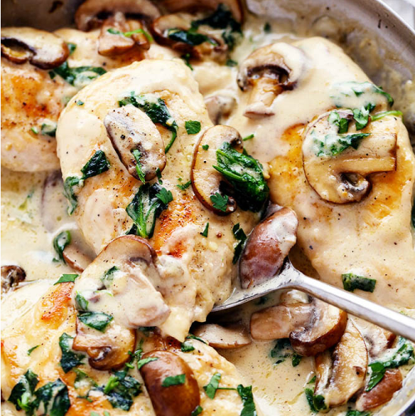
Creamy Parmesan Garlic Mushroom Chicken
Prep time 5 mins Cook time 20 mins

4 Servings

Ingredients
4 boneless skinless chicken breasts
2 Tbspolive oil
8 oz sliced mushrooms
¼ cup butter
2 garlic cloves, minced
1 Tbsp flour
½ cup chicken broth
1 cup heavy cream or half and half
½ cup grated parmesan cheese
½ tsp garlic powder
¼ tsp pepper
½ tsp salt
1 cup spinach, chopped
Directions
- In a large skillet add olive oil and cook the chicken on medium high heat for 5 to 6 minutes on each side or until brown on each side and cooked until no longer pink in center.
- Remove chicken and set aside on a plate.
- Add the sliced mushrooms and cook for a few minutes until tender. Remove and set aside.
- Melt butter in skillet.
- Add garlic and cook until tender.
- Whisk in the flour until it thickens.
- Whisk in chicken broth, heavy cream, parmesan cheese, garlic powder, pepper and salt.
- Add the spinach and let simmer until it starts to thicken and spinach wilts.
- Add the chicken and, mushrooms back to the sauce and serve over pasta as desired.

